Selector

1.ID 2. Class 3. Universal Selector 4.Grouping Selector

1. ID :

<html>

<head>

<style>

#para1 {

  text-align: center;

  color: red;

}

</style>

</head>

<body>

<h2>Id Selector</h2>

<p id="para1">Hello World!</p>

<p>With an external stylesheet file, you can change the look of an entire website by changing just one file!

</p>

</body>

</html>

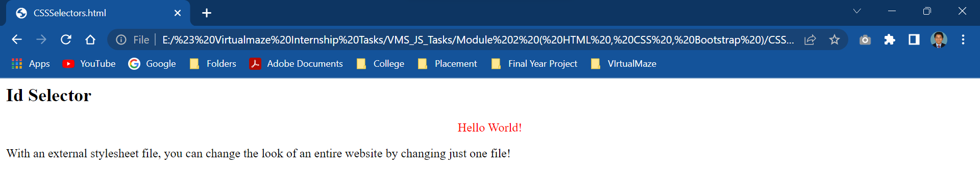

2.Class

<html>

<head>

<style>

.center {

  text-align: center;

  color: red;

}

</style>

</head>

<body>

    <h2>Class Selector</h2>

<h1 class="center">Red and center-aligned heading</h1>

<p class="center">Red and center-aligned paragraph.</p>

</body>

</html>

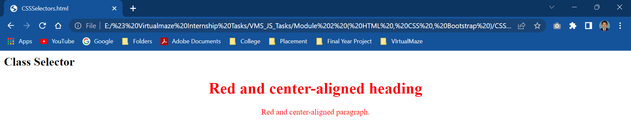

3.Universal Selector

<html>

<head>

<style>

\* {

  text-align: center;

  color: blue;

}

</style>

</head>

<body>

<h1>Universal Selector</h1>

<p>Every element on the page will be affected by the style.</p>

<p id="para1">Hello</p>

<p>Welcome</p>

</body>

</html>

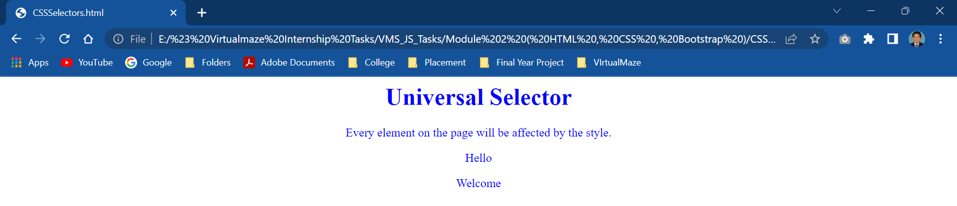

4.Grouping Selector

<html>

<head>

<style>

h1, h2, p {

  text-align: center;

  color: red;

}

</style>

</head>

<body>

<h1>Grouping Selector</h1>

<h2>How are you</h2>

<p>I am Fine !!!</p>

</body>

</html>

